Assignment 2- Introduction To Data Science

Instructions:
- Submit only one colab (.ipynb) file and one this report file (.pdf).
- Files should be named as yourrollnumber.ipynb (22L7521.ipynb, 22L7521.pdf)
- You are provided with three dataset files (Iris, Titanic, Housing ) .csv files
- You have to provide code for all three datasets of the necessary steps described in the tables of each question.
- Only the mentioned columns/features mentioned for each dataset should be used.
- IN Q.2 you are only required to make the histograms and leave the BoxPlot part.
Part A. Preprocessing
1. In this step, you are required to apply the preprocessing steps that you’ve covered in the course. Specifically, for each of the input dimension, fill in the following (add rows and complete the table for all input dimensions).
Iris:
Dim Name | Data Type | Total Instances | Number of Nulls | Number of Outliers | Min. Value | Max Value | Mode | Mean | Median | Variance | Std_Dev
SepalLength | float64 | 150 | 0 | 0 | 4.3 | 7.9 | 5.0 | 5.843333333333334 | 5.8 | 0.6856935123042505 | 0.8280661279778629
SepalWidth | float64 | 150 | 0 | 4 | 2.0 | 4.4 | 3.0 | 3.0540000000000003 | 3.0 | 0.18800402684563763 | 0.4335943113621737
PetalLength | float64 | 150 | 0 | 0 | 1.0 | 6.9 | 1.5 | 3.758666666666666 | 4.35 | 3.1131794183445156 | 1.7644204199522617
PetalWidth | float64 | 150 | 0 | 0 | 0.1 | 2.5 | 0.2 | 1.1986666666666668 | 1.3 | 0.5824143176733784 | 0.7631607417008414

Titanic:
Dim Name | Data Type | Total Instances | Number of Nulls | Number of Outliers | Min. Value | Max Value | Mode | Mean | Median | Variance | Std_Dev
Age | float64 | 714 | 177 | 11 | 0.42 | 80.0 | 24.0 | 29.69911764705882 | 28.0 | 211.0191247463081 | 14.526497332334044
SibSp | int64 | 891 | 0 | 46 | 0 | 8 | 0 | 0.5230078563411896 | 0.0 | 1.2160430774662894 | 1.1027434322934275
Fare | float64 | 891 | 0 | 116 | 0.0 | 512.3292 | 8.05 | 32.204207968574636 | 14.4542 | 2469.436845743117 | 49.693428597180905

Housing Prices
Dim Name | Data Type | Total Instances | Number of Nulls | Number of Outliers | Min. Value | Max Value | Mode | Mean | Median | Variance | Std_Dev
Area | int64 | 545 | 0 | 12 | 1650 | 16200 | 6000 | 5150.54128440367 | 4600.0 | 4709512.057575553 | 2170.141022508803
Price | int64 | 545 | 0 | 15 | 1750000 | 13300000 | 3500000 | 4766729.247706422 | 4340000.0 | 3498544355820.5796 | 1870439.615657394
Bedrooms | int64 | 545 | 0 | 12 | 1 | 6 | 3 | 2.9651376146788992 | 3.0 | 0.5447382622773889 | 0.738063860568575
Bathroom | int64 | 545 | 0 | 1 | 1 | 4 | 1 | 1.2862385321100918 | 1.0 | 0.2524757150566683 | 0.502469616053218
Stories | int64 | 545 | 0 | 41 | 1 | 4 | 2 | 1.8055045871559634 | 2.0 | 0.7525431732326017 | 0.8674924629255298

2. For each of the input dimension, plot histogram and comment the type of distribution the dimension exhibits. Further, visualize each dimension using a Box Plot. Specifically, for each of the input dimension, you’re required to fill the following table (duplicate it for each of the 15 dimensions).
Iris:
SepalLength
Histogram | Box Plot
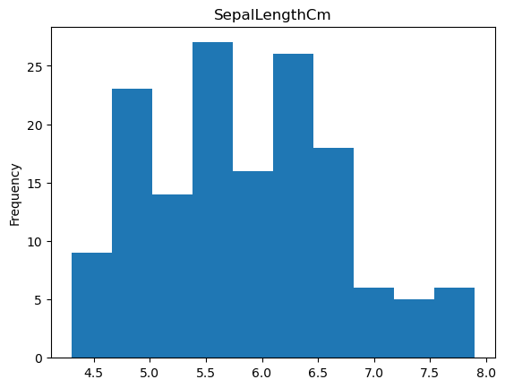 | 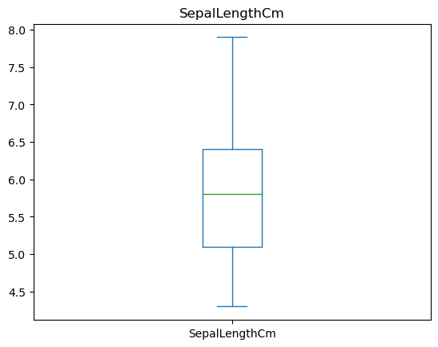
Comments: a mix of normal distribution and left skew, shows that most flowers were 5.5 cm but many were in intervals, common | Comments: a large upper bound present and no upper quartile present , mean appears to be at <5.5 cm, due to slight normal distrbution mean, median and mode might appear at same point.

PetalLength
Histogram | Box Plot
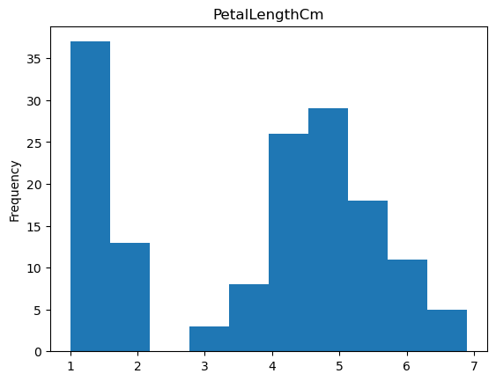 | 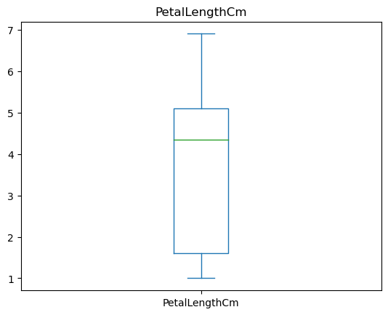
Comments: Many flowers had 1 cm length and none were in 2.5, subsequently we get a left skew after gap in reading, no outliers | Comments: a large upper bound present as most of the data was after 3cm, however the mean was influenced due to many readings after 3cm, thus a mean of <4 cm

PetalWidth
Histogram | Box Plot
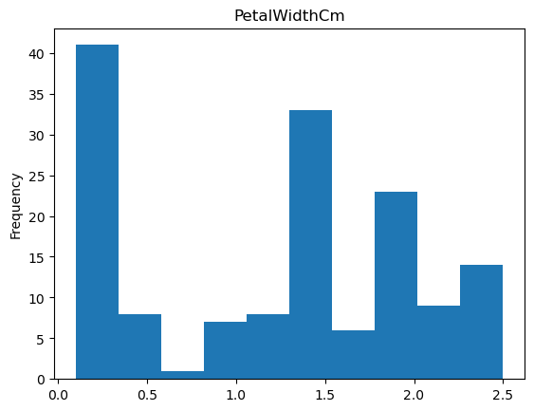 | 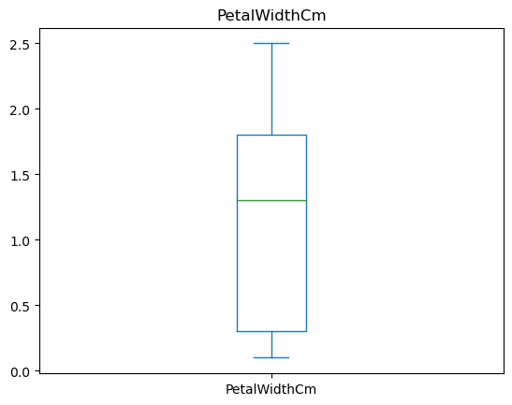
Comments:a big U can be seen in 3 points with difference of 1 cm, most of the flowers appear to have less width on average | Comments:due to a large spread of data mean is appearing in middle of data, a very large upper bound can be seen

SepalWidth
Histogram | Box Plot
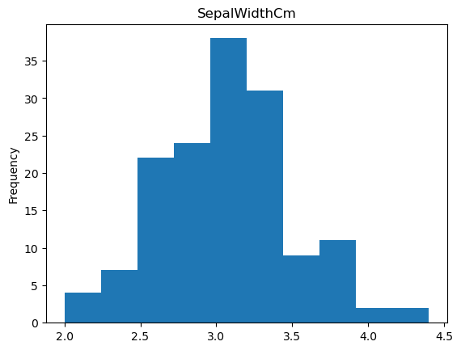 | 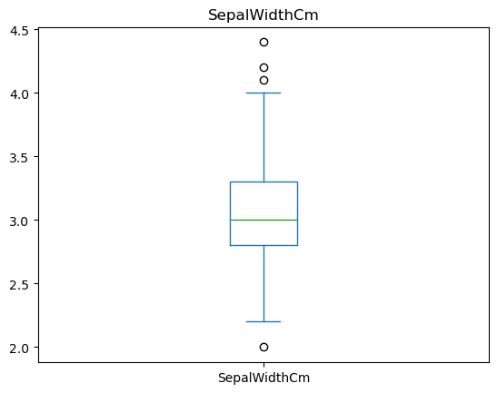
Comments:normal distribution of data present, mean, median and mode may appear at a same point as a result | Comments:4 outliers present and a small box, due to slight normal distrbution mean, median and mode might appear at same point.

Titanic:

Age
Histogram | Box Plot
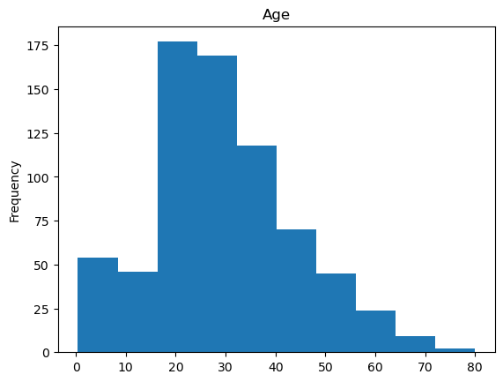 | 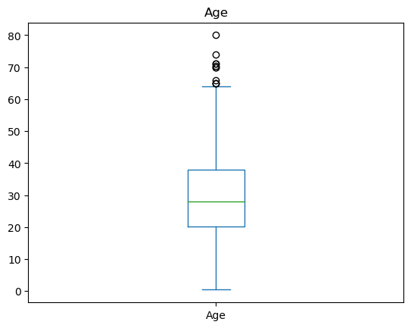
Comments:data has a right skew and a slight peak in start, indicating younger passengers were common | Comments:age is shown to have an average of 30, however many outlers exist, due to slight normal distrbution mean, median and mode might appear at same point.

SibSp
Histogram | Box Plot
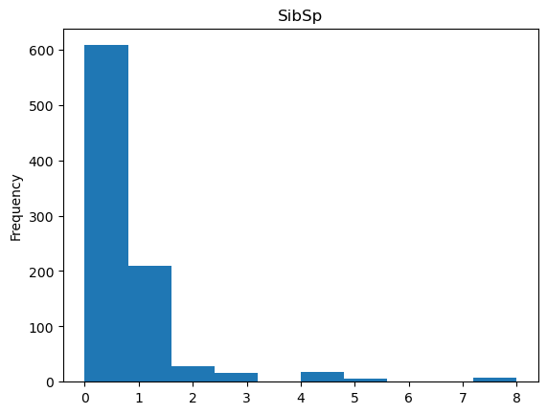 | 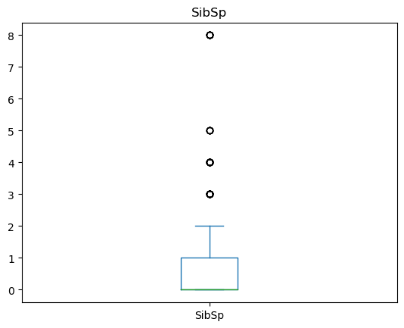
Comments:extreme right skew, clearly shows most of the values started near 0-1 | Comments: many outliers exist, first few in even intervals and one extreme, also the 1st quartile appears to be at the start of the plot

Fare
Histogram | Box Plot
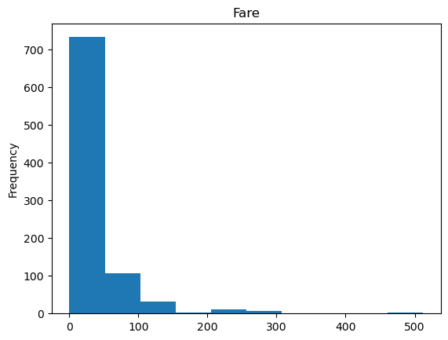 | 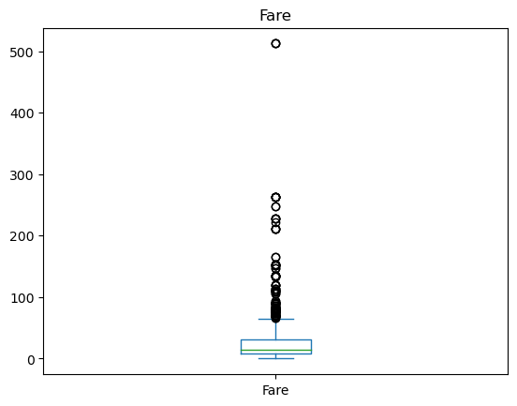
Comments:extreme right skew, clearly shows most of the values started near 0-100 | Comments: a extremely compressed plot shows that many paid the base fare, however a lot of outliers exist, which shows many paid for luxury class etc.
Housing Prices:

Area
Histogram | Box Plot
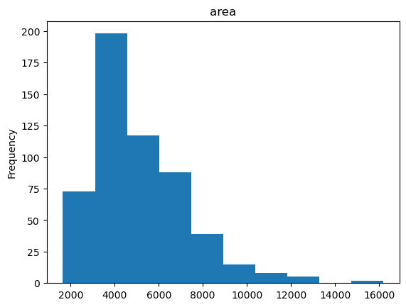 | 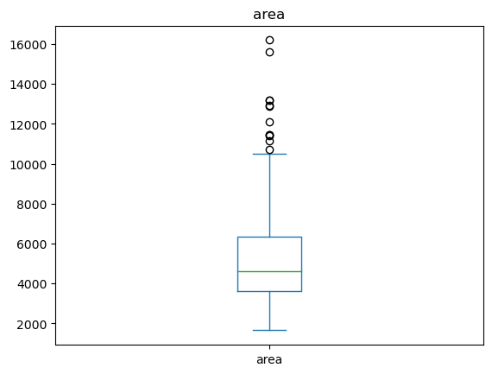
Comments:area and prce follow almost the same trend a perfect representation of real world data | Comments: perfect representation of average area, the higher bound and outliers, due to slight normal distrbution mean, median and mode might appear at same point.

Price
Histogram | Box Plot
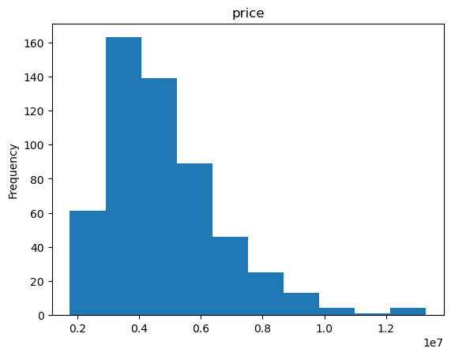 | 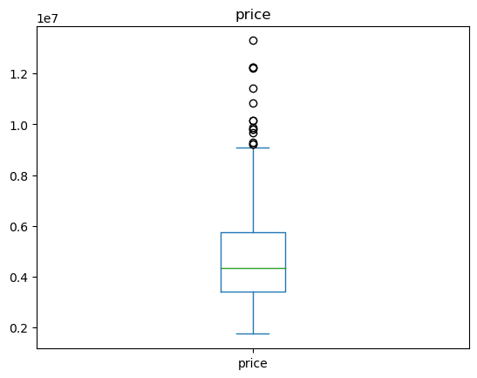
Comments: area and prce follow almost the same trend a perfect representation of real world data | Comments: perfect representation of average area, the higher bound and outliers, due to slight normal distrbution mean, median and mode might appear at same point.

Bedrooms
Histogram | Box Plot
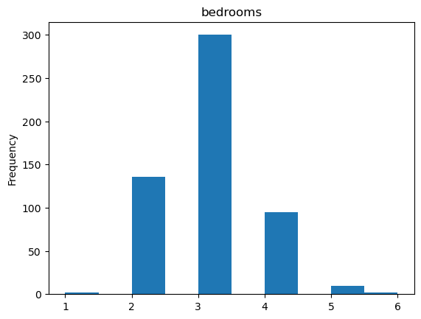 | 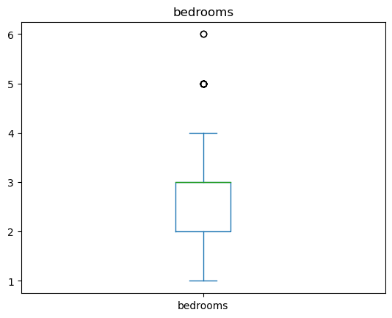
Comments: most of the houses had 3 beds, very few had 1 or 5 beds, after that 2 were normal and 4 were fewer than that | Comments: conveys same as the histogram a near perfect box plot and clearly shows outliers present at 5 and 6 bedrooms, mean line of data seems to exist near start of upper bound

Bathrooms
Histogram | Box Plot
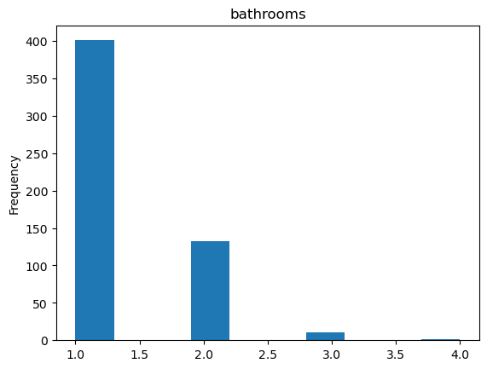 | 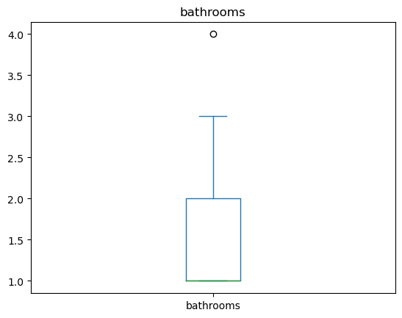
Comments: most of the bathrooms were 1 after that were 2 and after that 3 | Comments: same comment as histogram and looks like there was no lower bound, one outlier present at 4 bathrooms, mean line of data seems to start at the very start of data as presented by histogram

Stories
Histogram | Box Plot
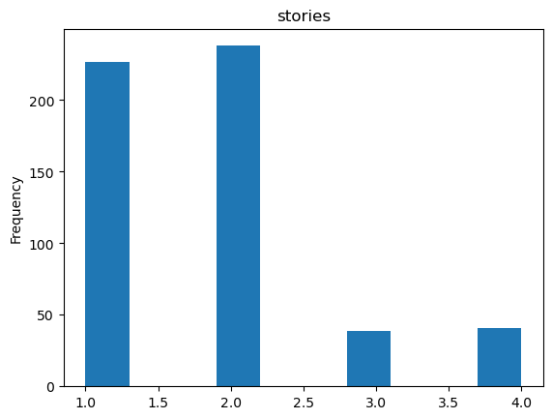 | 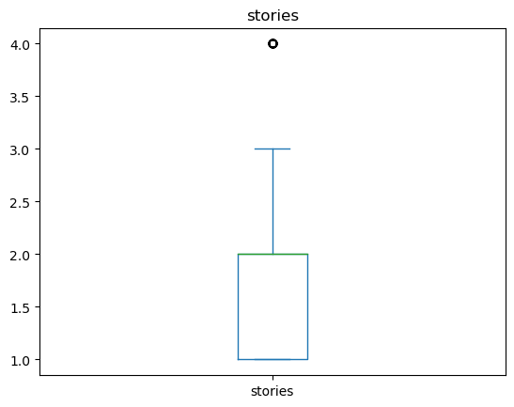
Comments: most houses were 2 stories and then 1 story, but there seems to be a few who are 3 and 4 stories | Comments: same comment as before box plot, there appears to be an outlier present at 4 stories, mean line of data seems to exist near start of upper bound

3. Find the missing values in each of the dimension (do this for both input and output dimensions), and fill these using an “appropriate” methodology that we’ve discussed in the class. You may also choose to drop a certain sample based on your analysis. Mention your approach and its justification.

Iris:
Dim Name | Number of Missing Values | Filled using OR Dropped | Reason for selecting a certain approach
SepalLength | 0 | - | No nulls present
SepalWidth | 0 | - | No nulls present
PetalLength | 0 | - | No nulls present
PetalWidth | 0 | - | No nulls present
Titanic:

Dim Name | Number of Missing Values | Filled using OR Dropped | Reason for selecting a certain approach
Age | 177 | mean | Can be dropped as it is useless unless we are going to train it
SibSp | 0 | - | No nulls present
Fare | 0 | - | No nulls present
Housing Prices:

Dim Name | Number of Missing Values | Filled using OR Dropped | Reason for selecting a certain approach
Area | 0 | - | No nulls present
Price | 0 | - | No nulls present
Bedrooms | 0 | - | No nulls present
Bathrooms | 0 | - | No nulls present
Stories | 0 | - | No nulls present

4. For each of the dimension, find out the outliers (noisy data) and handle these appropriately.
Iris:
Dim Name | Number of Outliers | Smooth using/ Dropped | Reason for selecting a certain approach
SepalLength | 0 | - | No outliers present
SepalWidth | 4 | dropped | SepalWidthCm has outliers, we remove them, 2.67% of the data was outliers
PetalLength | 0 | - | No outliers present
PetalWidth | 0 | - | No outliers present

Titanic:

Dim Name | Number of Outliers | Smooth using/ Dropped | Reason for selecting a certain approach
Age | 11 | dropped | Age has outliers, we remove them, 7.41 of the data was outliers
SibSp | 46 | dropped | SibSp has outliers, we remove them, 5.16 of the data was outliers
Fare | 116 | dropped | Fare has outliers, we remove them, 13.02 of the data was outliers

Housing Prices:

Dim Name | Number of Outliers | Smooth using/ Dropped | Reason for selecting a certain approach
Area | 12 | dropped | area has outliers, we remove them, 2.20% of the data was outliers
Price | 15 | dropped | price has outliers, we remove them, 2.75% of the data was outliers
Bedrooms | 12 | dropped | bedrooms has outliers, we remove them, 2.20% of the data was outliers
Bathrooms | 1 | dropped | bathrooms has outliers, we remove them, 0.18% of the data was outliers
Stories | 41 | dropped | stories has outliers, we remove them, 7.52% of the data was outliers

